Wetland a major tool for rural development and river pollution control
Dinkar Saxena
M.Sc., M.I.E., C.Eng. F.I.P.H.E, PGDM (A), Chartered Engineer; Email: dinkar@wateronline.co.in
CEO, Dass Rasayanic Services

Ashish Sharma, Virat Choudhary
Scholar at Department of Environmental Engineering
Hindustan College of Science and Technology, Farah, Mathura
Email: ashishqhse@gmail.com, viratchaudhary92@gmail.com

Abstract
There are various tools by which one can use the runoff water and utilize it for increasing water table and keep the biodiversity maintained. This paper explains the working and success story of Kakreta wetland, near Yamuna River. Wetland means a depression on the surface where runoff water gets collected from various other sources (like rainfall, rain drains from city etc.). It can be natural or artificial. Also wetland can be a field filled with water along with tall grasses in it; its major aim is to protect the biodiversity and to treat the waste water by natural processes.
Generally, wetlands are lands where saturation with water is the dominant factor determining the nature of soil development and the types of plant and animal communities living in the soil and on its surface (Cowardin, December 1979). Wetlands vary widely because of regional and local differences in soils, topography, climate, hydrology, water chemistry, vegetation, and other factors, including human disturbance. Indeed, wetlands are found from the tundra to the tropics and on every continent except Antarctica.
Introduction
A large part of Indian economy is based on monsoon. Even with having such fast development activities going on, the dependence on monsoon isn’t reduced. On an average India receives 1170mm of rainfall annually, yet some parts are still suffer from the scarcity of drinking water.
Gailana and Kakreta are the two villages in Agra near Yamuna River, which has been marked as the suitable site for water conservation by Samajik Vaniki Prabhag, Agra. The watershed lies in between E 77º 26’ 78.8 º N 26 º 26’ to 27 º 26’ which is more than 500ha forest area. From this site 8 drains fall into the Yamuna River which carries the waste water contaminated of chemical substances and insoluble solid particles released from city. Rain water also gets enter into this drain which runs throughout the year. And due to the initial condition of this site this water wasn’t get collected prior than our efforts. It was planned to collect and conserve the waste water, under a programme named as Development of Yamuna Wetland. 9 ponds were to be constructed according to this plan on the upstream side of this stream by forming check dams into its way. The scheme was funded by MANREGA.

Base Line Conditions
Past condition of watershed was pathetic in year 2009, due to built-environment, higher runoff from highland and residential area has cause massive erosion and fertile soil is transported to river Yamuna.
- In post monsoon months there is hardly any moisture in soil, thus there is no large leaf tree in catchment area. This is evident from Google images.
- Due to very less vegetation in catchment area, absorption of water in soil is poor. Catchment generates higher runoff resulting, soil erosion, thus ravines are formed as deep as 11 m due to unchecked runoff during the monsoon.
- The catchment was used as grazing ground by Villages surrounded by it. Tree are cut for fire wood, thus all effort by Forest department was in vain.

Previous Efforts for restoration of ecology
- Planation of Babool, a hardy plant, but requirement of firewood by nearby villagers destroys ecology.
- Grazing of animals from nearby population and almost no moisture in soil has dent of plantation of grass.
- In year 2006 forest department installed earthen bunds, which could not survive due to flood and other factors.
Constraints for planning
- Total budget allocated for the project was of Rs. 284 lakh.
- The land has steep slopes with many depressions formed due to erosion.
- Although land belongs to forest department it was objected by the villagers, because it was used as a grazing site.
- Entering of floating inorganic materials into the stream.
- Rainfall runoff was to be utilized of a large area of 500ha.
Terrain Description
- The surface has a steep fall of 11m from entrance to the discharge point and drain length was about nearly 3 km.
- Due to soil erosion caused by this flowing stream some depressions were formed on the surface along the bank of river Yamuna also.
Methodology adopted for designing
There are three types of constructed wetlands, using reed beds, are in use. All these systems are used commercially, usually together with septic tanks as primary treatment, Imhoff tanks or screeners in order to separate the solids from the liquid effluent).
System types are:
- Surface flow (SF) Constructed Wetland (or reed bed)
- Sub Surface Flow (SSF) Constructed Wetland (or reed bed)
- Vertical Flow (VF) Constructed Wetland (or reed bed)
Thus following scheme was selected

Pre-Treatment
Waste water reaching to the watershed, is pre-treated for the removal of unwanted and easily separable material. For that purpose raw waste water is passed from screen and sedimentation tank are design to reduce the velocity of flowing stream as low as 0.2 M/S at expected peak storm water runoff.
Design considerations for wetland
The following process design norms for constructed wetlands were selected for design (please refer to table 1), but these norms cannot be applied directly to a warm country like India without adjustment.
Table 1
Parameters | European Value | Recommended for India
Area requirement (m²/person⁽¹⁾)  BOD₅ loading rate, g/m²-day⁽²⁾  Detention time, days  Hydraulic loading rate, mm/day  Depth of bed, meters  Porosity of bed,%(typical)  1st Order reaction constant, K_{T}/day  Evapotranspiration losses, mm/day⁽³⁾ | 2.0-5.0  7.5-12.0  2-7  (must not exceed hydraulic conductivity of bed)  10-15 | 1.0-2.0  17.5-13.5  2-3  0.6-0.9  30-40  0.17-0.18  >15
- Constructed wetlands may be suitably downsized when waste water is preheated
- Based on raw sewage BOD= 50g/person-day and 30% reduction in pre setting
- 1.0mm/day = ha-day
Source- Waste water treatment for pollution control and reuse(Tata McGraw-Hill Professional)
For the design of macrophyte beds with horizontal flow, two important aspects of design had been kept in mind. These are:
- Organic removal parameter, and
- Hydraulic flow considerations.
Design for organic removal:
BOD removal has been approximated by first order, plug flow kinetics. On the basis of European design and operations guidelines for these systems, Green and Upton(1994) give the following based on first order kinetics as also used in Severn Trent, UK, for the design of constructed reed beds for polishing waste water treated effluents from small communities:
C_{t}=C_{o}e^{-Kt}
Since t is a function of bed area, it can also written as
A= Q (ln C_{o} – ln C_{t})/ K_{BOD}
In which, A= bed area, m2
Q = average flow, m3/day
C_{o}= inlet 5-day BOD, mg/l
C_{t} = Outlet BOD₅, mg/l
K_{BOD} = BOD₅ reaction constant, day⁻¹
As per the Severn Trent report, the value of K_{T} for 49 systems in Denmark is observed to average 0.083 and in UK it is 0.067 per day. For Bangalore, India, with domestic wastewater Rengasami et al.(2002), the KT value as 0.17 per day which is likely to occur in a warm country.
Calculations
- For Bed area
Catchment Area= 500ha approx.
Population= 100/ha average
Flow rate= 5 MLD expected
BOD= 300 mg/l
K_{BOD}= 0.18/day
A= Q (ln C_{o} – ln C_{t})/ K_{BOD}
As per Kinetic equation for first order reaction
A= 0.145(ln 300 –ln 30)/0.18 = 1.85 m² /person
Total Area required= 1.85x500x100=92500 m²
- BOD load

BOD load per person= 300 mg/ltr x 145 ltr/day = 43.5 g/person/day
Hence BOD loading on bed = 43.5/1.85 = 23.5 g / m²/day
(This is within the recommended limit)
Mitigation employed on watershed
- Calculation for area for wetland as per site conditions
Total gradient available is 11m
Total bed Area required = 9.25 ha
Depth of each unit selected is 1m for reducing the cost of weir, thus total No of check dam can be constructed is 8 or max 9
or it requires 9000m² (approximately) / check dam. Weir is to be constructed at each 1m gradient fall
- At all the drains carrying domestic drainage to forest land, development of 1 m deep ponding areas, by stone pitching at required Contours generating from end of valley ridge line..
- A proper water segregation system is designed for separation of floating material, non-biodegradable garbage material in to wetland. Rainwater runoff is designed to be taken to rainwater harvesting area.
- All the highland area is having contour bunds and rainwater recharging areas, thus reducing the runoff to valley or wetland area. Reducing the chances of wash off of wetland.
- Three types of (non-predatory) fish are chosen to ensure that the fish can coexist & contribute to sustainable wetland ecology.
They are
- Surface feeders
- Middle-ground swimmers; and
- Bottom scavengers
- Before discharging water in to river water will pass through subsurface wetland to give polishing touch besides restoring ecology of ravine.
Present Scenario
- Restoration of wetland ecology: Bamboo has taken over the Babool as evident in the plate 2
- Wastewater treatment. BOD measured at the discharge point is measured is approximately 70% less than from the loading point.
- Production of fish:
- Increment of soil moisture regenerated the local vegetation such as Typha, Canna Indica, bamboo etc. Resulting Reduction of soil erosion.as evident from the plate 2
- Increment in ground water level. Piezometer installed by forest department indicates 15 ft rise in ground water
- Control over Eutrophication

YEAR (2009) YEAR (2012)
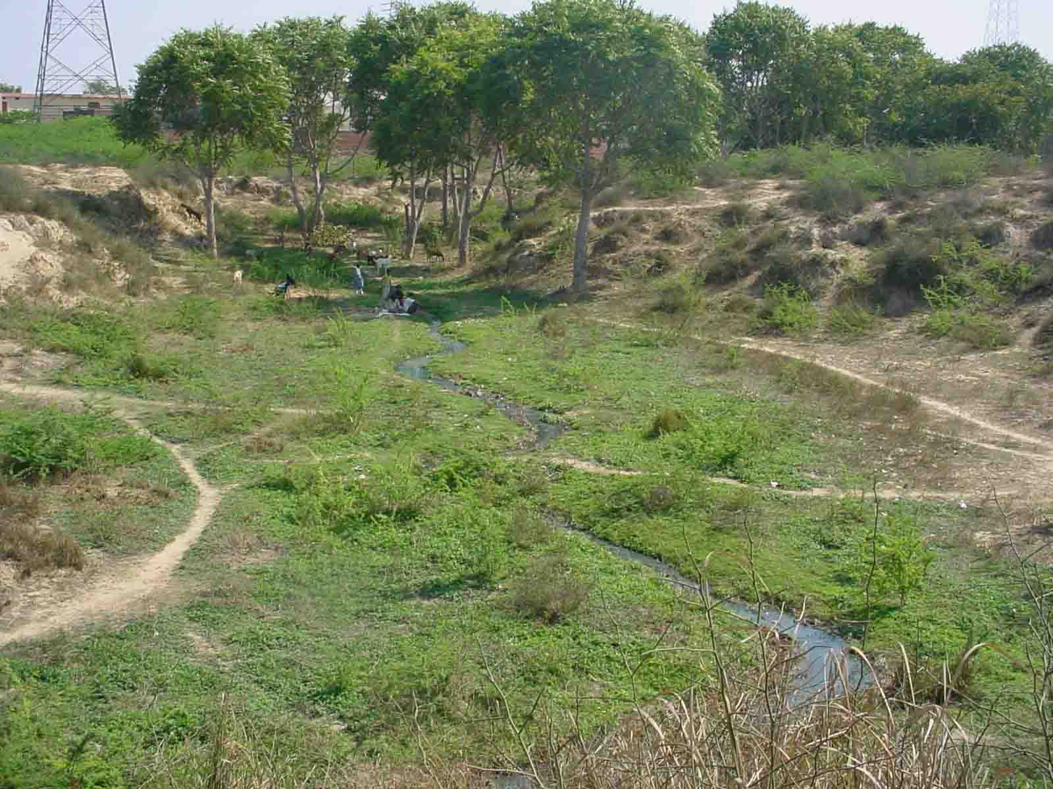
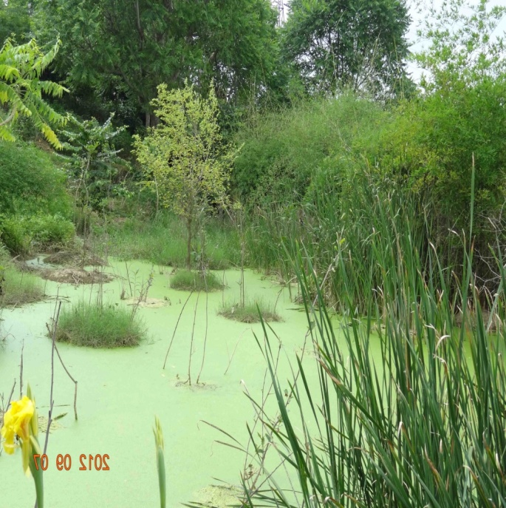
Plate 1 • Structure no.1
Plate 2

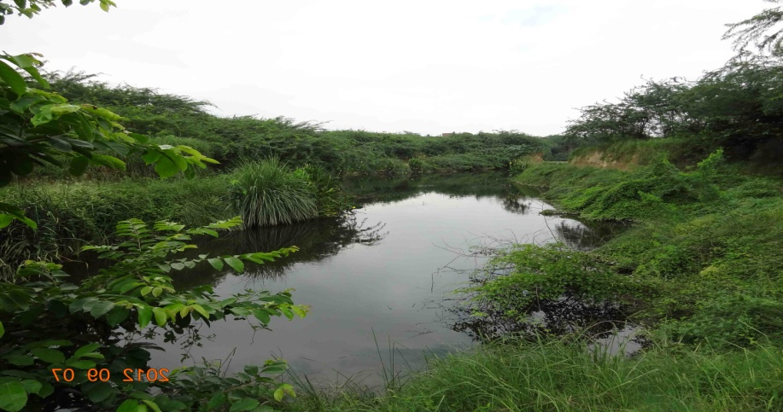
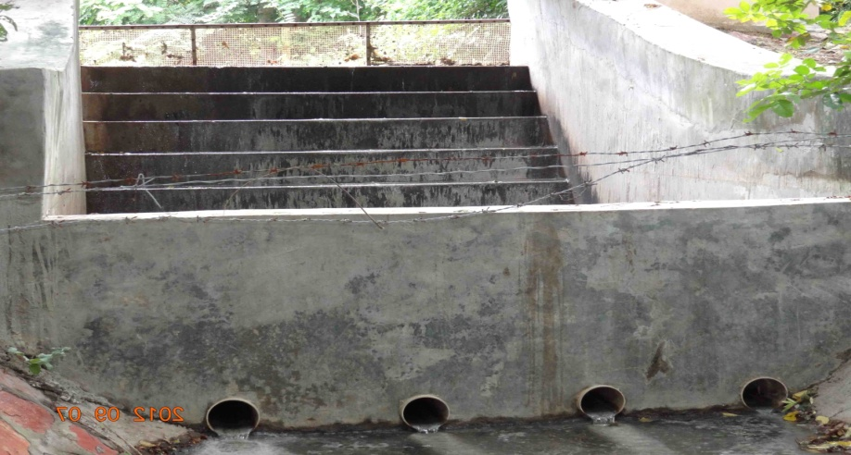
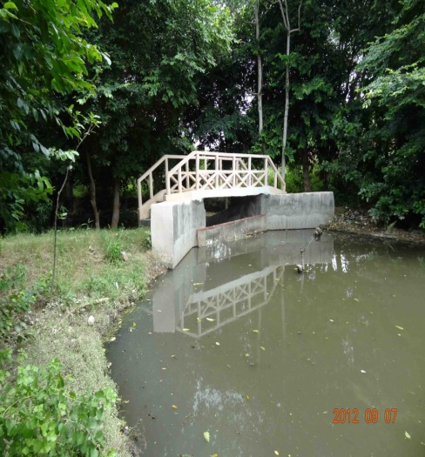
Plate 3 constructed check dam
Plate 4 • Structure no.2
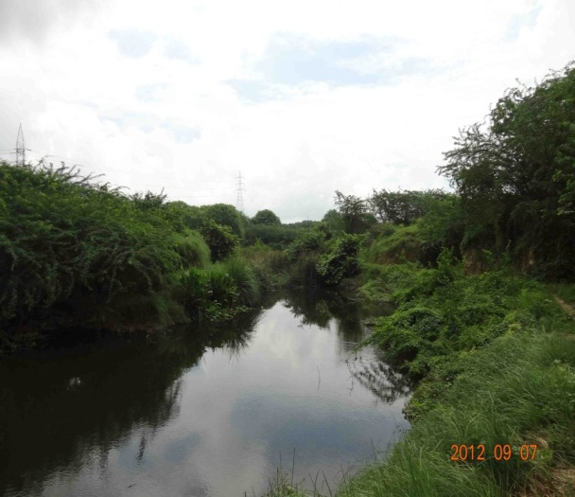

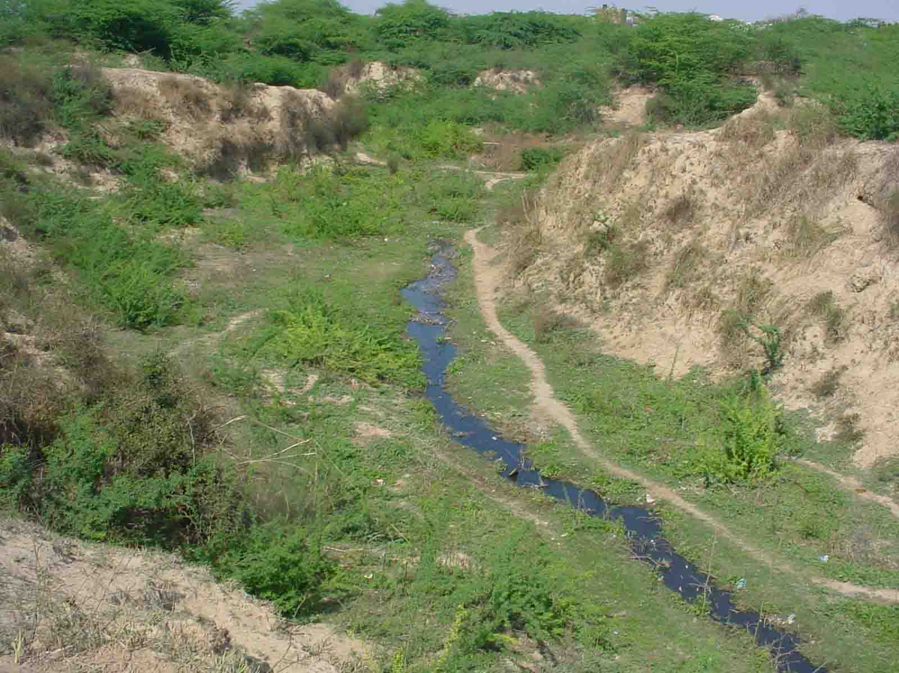
Plate 5 before construction (year 2009)

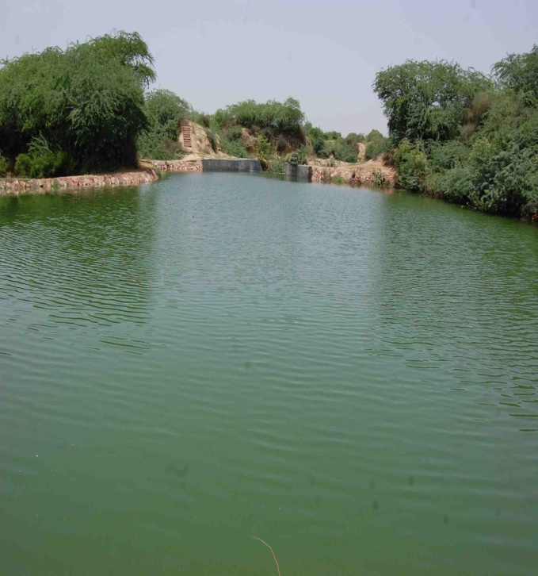
Plate 6
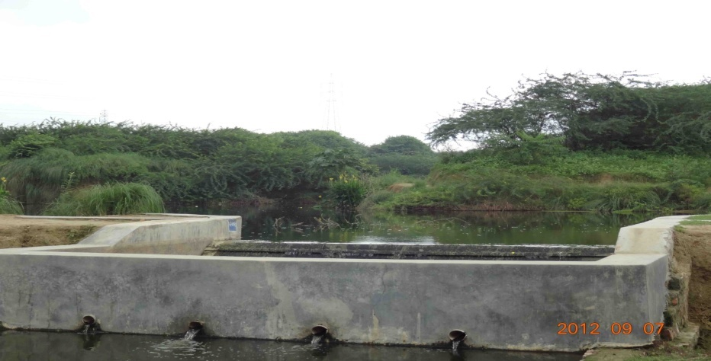

Plate 7 After construction ( year 2012)

Citations
  - Waste water treatment for pollution control and reuse(Tata McGraw-Hill Professional)
  - Constructed wetland systems -Design Guidelines for Developers
  - EPA Regulations listed at 40 CFR 230.3(t)]
  - The effect of heavy metals accumulation on the chlorophyll concentration of Typha latifolia plants, growing in a substrate containing sewage sludge compost and watered with metaliferus water by a, Thrassyvoulos Manios n*, b Edward I. Stentifordn n, c Paul A. Millnern
  - E COWARDIN SYSTEM OF WETLAND CLASSIFICATION (1979) AND THE NATIONAL WETLANDS INVENTORY (NWI)

